Eyes on the Tsolum River Year 2
Summary of June 2023 Observations

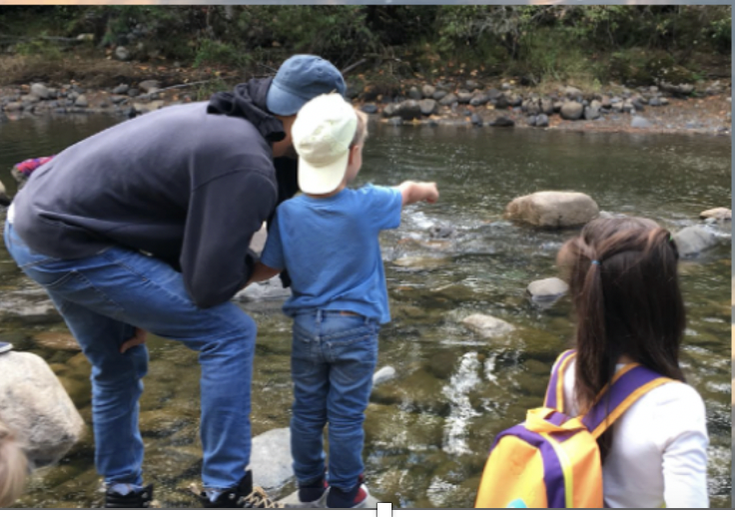

Eyes on the Tsolum River (ETR) is a group of individuals and families that walk the Tsolum River and report their observations to myself Allan Chamberlain, a Tsolum River Restoration Society (TRRS) outreach volunteer and retired Fish and Wildlife Professor.

The information gathered includes fish and other wildlife sightings, water quality data, and general observations about the status of the river and watershed. The findings are summarized periodically and circulated to all of the observers.
Sharing information creates a better understanding of the Tsolum watershed and the status of its native fish. Using this information, we can identify focus areas for restoration and advocate for best practices for fisheries management, with the goal of improving the well-being of the native fish.

The following pages are the observations and water quality sampling made by Eyes on the Tsolum River Volunteers in June, 2023. For more details, the following see pages and the Appendices.

Summary of the Eyes on the Tsolum River Observations in June, 2023
Mid to upper reaches of the Tsolum River. Lower to mid reaches of theTsolum River.
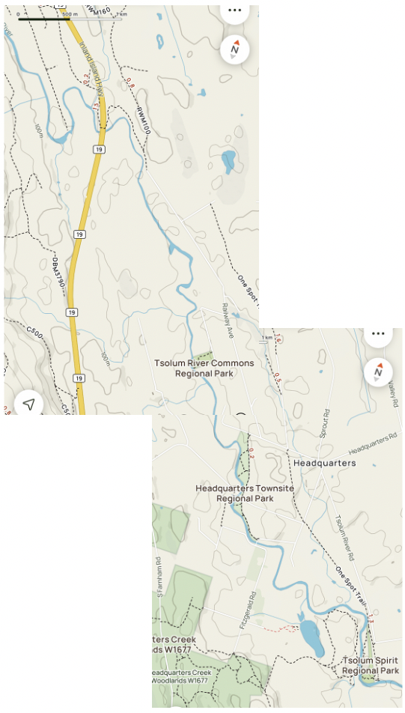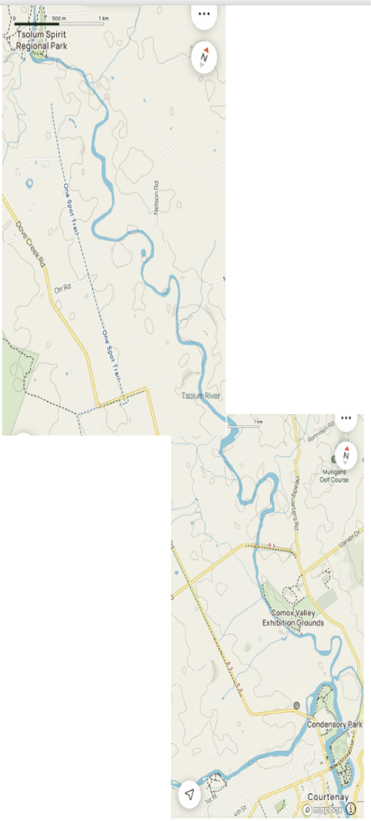
Healthy Coho Salmon fry
W.temp = 17.1 C, June 11

Healthy Chinook
Salmom fry. 19
Caught in the
RST, June 4.
Healthy Coho Salmon fry,
W.Temp = 22.3C
June 12.

Salmon fry observed migrating upstream over rock dam. June 14.
W.Temp 18.7C. at 1.35pm
Stranded Coho Salmon fry rescued, Godin Pool Spawning Channel, June 6.
100+ Stranded Coho
Salmon smolts
Rescued, River Ave
Pond in June 1-16.
0&1 year old PS. Sunfish caught, June 12.
Upper Portuguese Cr. (not on map) Sackville Rd. No Coho Salmon fry present this spring, May and June. Note: last spring 400 Coho fry were rescued along this stretch.
Fish Kill, 100s of
1&2 year old
Coho Salmon
Smolts. June 11,

Sightings of Invasive Pumpkinseed Sunfish (Lepomis gibbosus) in the Tsolum Watershed.

This invasive species was first discovered by Graham Hilliar, a TRRS volunteer, in June, 2022 in minnow traps set in Wildwood Marsh and its outflow, Smit Creek, that eventually runs into lower Tsolum River. On June 26 this year, Graham observed schools of larval and juvenile Pumpkinseed Sunfish (PS) and sample netted some. Also, Cloverleaf trapping in May, and now in June, show that they are now residing in the main stem of the lower Tsolum River
.
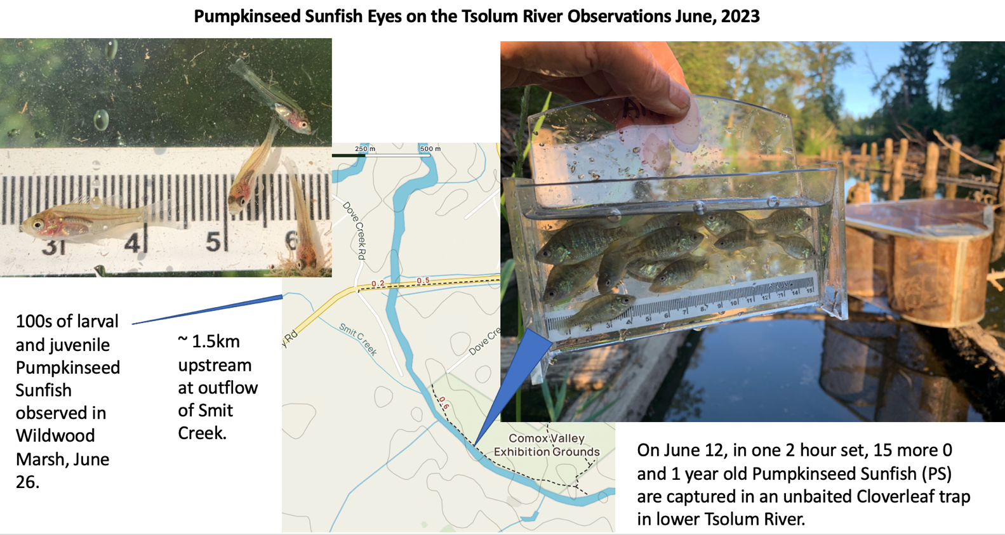

Interestingly, no PSs were captured in 6 unbated Gee traps set in the same location

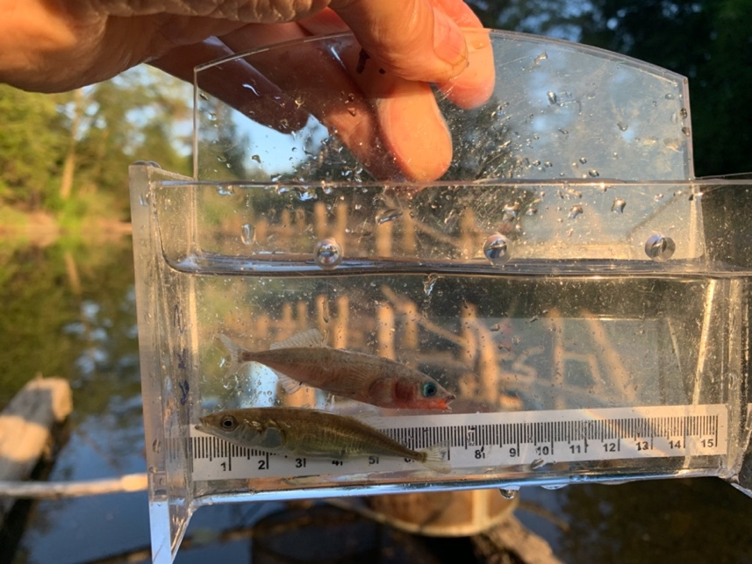
However, 100s of the estuarine variety of the native ThreeSpine Sticklebacks TSS) were captured in these G traps. The bright spawning colour of the males TSSs may be mistaken for an invasive species.
Observing and Rescuing Salmon Fry and Smolts
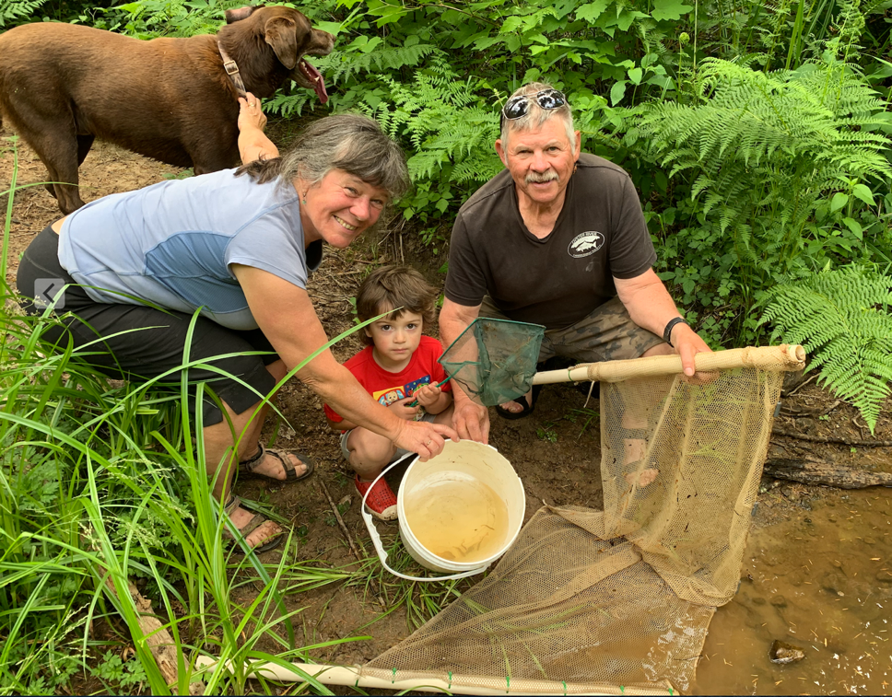
Many of the Tsolum tributaries and some spawning channels are drying up this past month and fish rescues are are ongoing (see June Appendix 1.) This family are rescuing Coho Salmon fry from rapidly drying pools in the Upper Tsolum tribs. Sadly, ATV tracks were observed going through these pools.

A number of ETR observers have have reported seeing coho fry at various densities (Appendix 1). They are the most common salmon fry seen in the summer are relatively easy to identify in a fish viewer with their distinct orange -coloured fins a large sickle shaped anal fin.

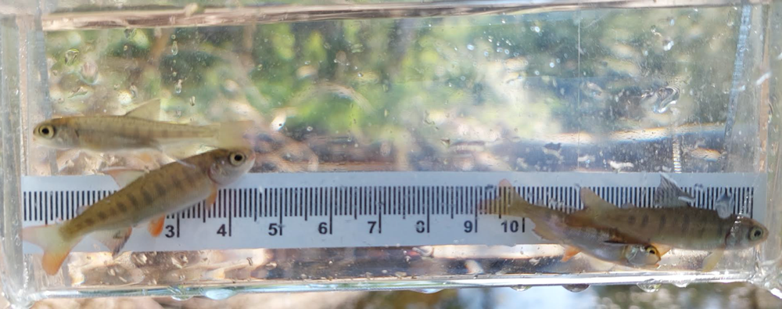
In the TRRS chinook fry are captured in rotating screw trap (RST). Their fins are more yellowish with no sickle.
Keep in eye out for these fish, and if you different looking salmon fry, please take a picture of them and send it to me
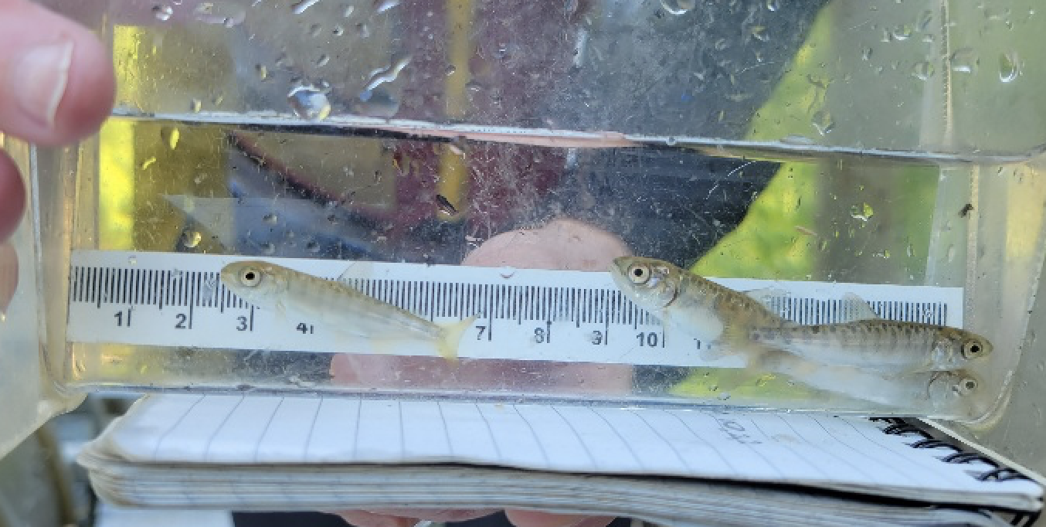

The third Fish Kill of Coho Salmon Smolts in Consecutive Years in Chilli Creek
On June 12 at 6.54pm in Chillie Creek, 1 & 2year old Coho Salmon were observed dead and stressed (breathing rapidly on the surface). These fish were found along 150m of this stagnant blind channel from its confluence with the Tsolum River to 150m upstream.
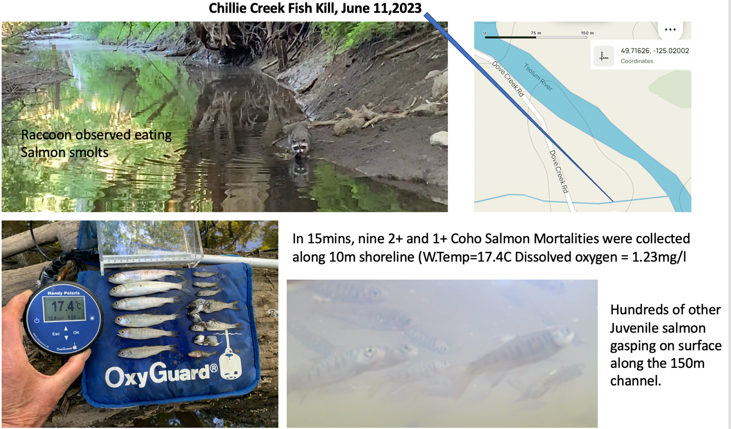
Raccoons were observed feeding on these dead and stressed fish and pieces of fish carcasses were found several meters from the shore in the bush. While a raccoon was feeding close by, 8 Coho Salmon mortalities were quickly collected along 10 meters of shoreline.
Because of the predation rate, and the number of fish mortalities not observed in the deeper water throughout the channel, it is impossible to calculate the total numbers of fish killed. However, judging by the 100s of stressed fish on the surface and evidence of partially eaten fish, fish losses were in the hundreds to possibly a few thousand.
On June 19, no dead or alive fish were observed in the 150m channel and very few predator tracts were evident, indicating that the remaining stressed fish had died and were eaten.
A number of people have asked, how many fish died in Chillie Creek? Because of the many valuables, this is difficult to answer but I’ve attempted to “guess” at it in Appendix 2.
Fish Movement, Flows and Water Quality
Initially in the spring very few ETR reports came in seeing large numbers of salmon fry in the mid and upper reaches of the main stem Tsolum or the tributaries. This was not surprising given given the very low flows last fall, restricting access to all species of salmon, apart from some very late spawning Coho Salmon. Consequently, 100s of stranded salmon fry that are annually rescued in the Upper Portuguese Creek were not there this year because no adult coho were able to reach these spawning grounds because of the low flows last fall (See Appendix 1 attempted fish rescue June 14.)
The good news however, was as the spring progressed into early summer more and more sightings came in of seeing salmon fry in the upper reaches. This indicates that the fry hatching in the lower Tsolum, were able to move upstream. Many thanks to the people who have opened up spillways in the rock dams to allow for this upstream fish migration to occur.
Because of the recent low from little or precipitation, water users have been moving their intakes closer to deeper channels (Thalweg) in the main stem Tsolum..
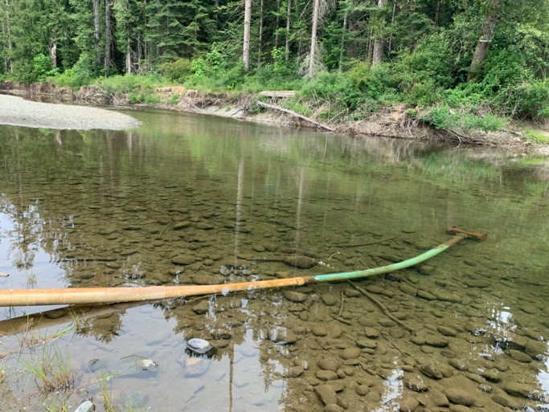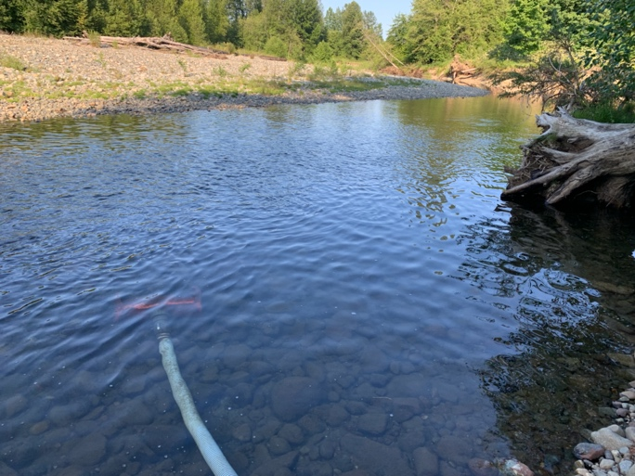

Some of these water intakes have broken mesh on their intakes. Please repair them to prevent salmon smolts and fry getting suck in the pump, especially if you are pumping at night.

With no rain and the very low flows, water temperatures in the Lower Tsolum have risen to 23C (see Mid to late June in Appendix 1). This is only 3C less than lethal incipient level for salmon fry. I’m afraid, if the heat and dryness continue, we shall begin to see salmon fry dying of heat stress in the lower Tsolum, especially sections where there is no riparian cover where water heats up first (see ETR Year 1 pages 12-13).

Lessons Learned and Recommendations

The following are my suggestions and do not necessarily reflect those of the TRRS.

1. Invasive Pumpkinseed Sunfish (PSs)
To date we only have ETR reports of PSs in the Tsolum Watershed in Wildwood Marsh watershed and the main stem of the river below the Piercy Rd Bridge. There is however, a report of PSs in the Mallard/Piercy watershed (Hamish Murray TRRS Director personal communications).
These recent findings show that PSs are spreading and could possibly be tolerant to brackish water and are able to move down the Tsolum and migrate up other watershed via the Puntledge river estuary during high tides? The other possibility is that it was another PS introduction?
What we know for sure is that PSs are reproducing in Wildwood marsh and migrating in high numbers into the lower Tsolum and we are now gone from an eradication to possibly a containment strategy. This requires an interdisciplinary team to discuss how to locate the adult PSs and develop methods to remove at them at spawning nest sites where they are most vulnerable to capture.

2. Fish Kill in Chillie Creek
This is the third consecutive year there has been a fish kill in this location in Chillie Creek in June. In the 2021 fish kill, many more samples of dead salmon were collected and a detailed report was written (Oates and Adebar 2021). These investigators recommended that, for future kills, Fisheries and Oceans Canada should be contacted as soon as possible by the person(s) witnessing the kill by calling the following numbers: Regional Office, Campbell River 250-850-5701 and Fish habitat and Protection Branch 1-866-845-6776. (These numbers were included in the ETR May Summary).
I discovered this recent fish kill in Chillie Creek at 7pm on a Sunday night on June11 after doing my regular walk along a section of the main stem Tsolum. At that time several raccoons were feeding of the dead and dying salmon smolts and there were juvenile salmon gilling rapidly on the surface. To record the event, I set up the Gropro camera in this 150 m stagnant channel and measured dissolved oxygen and water temperature (14.4C and 0.54mg/l) where the stressed fish were observed gilling on the surface. I also collected 8 complete carcasses of dead salmon smolts approximately 10m along the shoreline and 2 partially eaten carcass a few meters from the shoreline. While I was collecting these samples one of the raccoons stayed and carried on feeding on the salmon carcasses. Early the following day (Monday) I called in the fish kill using both numbers recommended and I received a call back the following morning and a subsequent follow up email (for details Appendix 2).
During the phone call with Ian Matchett, Senior Biologist, Fish and Fish Habitat Protection Program, I mentioned that, as in previous years, the low dissolved oxygen was recorded and the juvenile salmon were either dead or stressed, gilling rapidly on the surface.
In Ian’s follow up email he recommended to call the following departments for direct or potential fish kill situations:
- DFO’s Observe Record Report (ORR) is a 24/7 toll free tip line to report physical damage to fish habitat, death of fish, and deposits of sediment in fish habitat
- Toll free 1-800-465-4336 or by EMAIL: DFO.ORR-ONS.MPO@dfo-mpo.gc.ca
- To report oily water, discharge of chemicals or sewage, or spills, that requires an immediate response, please call Environment and Climate Change Canada (ECCC) at 1-800-663-3456.
Obviously the two phones recommended in the ERT May summary did get a response from the appropriate agency, however using these additional numbers you may get a quicker response?

To avoid this annual fish kill in the future, I recommend a proactive approach by conducting a fish rescue as soon as Chillie Creek becomes a blind channel in the spring. This could be done with 4 volunteers in approximately 2-3 days by Cloverleaf trapping and seine netting. Every effort should be made to get these extremely valuable healthy fish into the main stem Tsolum during the smolt window when water temperatures are favourable for fish migration to the sea.

Appendix 1. Eyes on the Tsolum River Daily Reports from Observers in 2023.
(S= Surface B=Bottom, and D.O. = Dissolved Oxygen in milligrams per litre)

W.Temp. D.O. Initials
March
28. 11.30am
Walked along the bank from the Confluence of Towhee Creek upstream for 200m. Water clear and flow good. Did not see any fish, salmon fry or other species. AC
April
30. Coho Salmon fry and Chum fry Gropro videoed in the main stem Lower Tsolum at the confluence of Towhee Creek that was flowing in to the mainstem. AC
May:
1. 170 Coho Salmon fry counted along the lower Tsolum River between the confluence of Towhee Creek and Meadow Farm Creek (~200m stretch) Size range of fish 32-41mmFL. AC
2. Upper Tsolum under HWY 19 bridge (12.00 hr): 6.9
Upper Tsolum 200yds upstream of HWY 19 bridge: 7.3
Upper Tsolum 600yds upstream of HWY 19 bridge: 7.4. W&J
4. Chilli Creek at the confluence of the Lower Tsolum River. Flowing with ~50 smolt size Coho Salmon and ~100 Coho Salmon fry observed in Gropro video at 13.25hr:
18 10.4
At 12.30 to 13,00 hr.
Chilli Creek at Culvert, Dove Creek Rd, surface reading: 14.9 6.9
Chilli Creek at Culvert, Dove Creek Rd, bottom reading: 13.4 6.8
Chilli Creek, midway down channel, surface reading: 14.5 6.7
Chilli Creek, midway down channel, bottom reading: 14.1 7.5
At 14.00hr at approximately 300m downstream of the Bottleneck Pool, ~60 Coho fry, average size 35mm FL and ~10 Chum fry (see pics).
At 15.00hr at approximately 50m downstream of the Bottleneck Pool, 100s of estimated 1-3 day old swim-up coho fry, 30-35mm FL (see pics).
Immediately upstream of Bottleneck Pool, no fry observed. 12.0. 10.2 AC
10. Spirit Park Pool 12.03hr. saw 3 Coho Fry in shallows. Walked 200m downstream counted 7 Coho fry – took Gropro video. 9.5. 10.7. AC
11. Pumpkinseed Sunfish Trap (PST) in Smit CreeK caught 4 Pumpkinseed Sunfish. HM
13. Morewood Site Lower/Mid Tsolum River. 13.4. 10.0. DM
14. Diane’s Pool (location?), 20 Coho Salmon fry SG
14. ~300m downstream of the Bottleneck Pool 200 salmon fry. SC
15. Upper Tsolum under HWY 19 bridge: no fish. 10.4
200yds upstream of HWY 19 bridge: 5 Coho fry 11.0
600yds upstream of HWY 19 bridge: 12 Coho Salmon fry (measured 1fish = 35mm FL)
11.0. W&J
15. At 19.21hr at approximately 200m downstream of the Bottleneck Pool, ~5 Coho fry, average size 39mm FL and ~5 Chinook fry? 29-32mm FL (see pics). AC
18. River Ave Pond, channel drying up fast catching 1+ smolts in Gee Traps. LO
20. Headquarters Park Deep Hole 50+ Coho fry SG
W.Temp. D.O. Initials

21. Lutkin Site, Mid Tsolum, 11.00hr. 10.5 11.0.
Spirit Park – lots of Coho Salmon fry. DM
21. Morewood Site Lower/Mid Tsolum River. 10.5 10.1. DM
23. Exhibition Grounds, Lower Tsolum:
Set 10 Gee traps un-baited from 11.30am-12.45pm (1.5hrs):
(Catch= (5) Coho fry 51,52,48,41,38mmFL. (6) Pumpkinseeds 41,38,39,36,39,35mmFL. (2) Prickly Sculpins. (45)ThreeSpine Sticklebacks.
Set Cloverleaf Trap un-baited 12.30pm-2.45pm (2.25hrs set):
(2) Coho smolts 95,100mmFL (2) Coho fry 38,37mmFL (11) Pumpkinseed 43,42,39,39,34,38,38,36,31,32 29mmFL. (see pictures in text) MV
23. Towhee Creek Ponds drying up. KG
24. Godin Pool Area. Continue to see Coho fry (43mm FL ) in Spawning Channel K&D
26. Towhee Creek Upper Deer Gate Pond.
Set, aerated, un-baited Cloverleaf Trap 11.45am- 1.15pm (May27) -25.5hrs set:
Catch (2) Coho smolts 96,116mmFL. 14.3. 1.06. MV
27. Towhee Creek Pond 2.
Set, aerated, un-baited Cloverleaf Trap 3.00pm- 8.30am (May27) -17.5hrs set:
(1) Pumpkinseed (90mmFL -see pic), (16) Coho fry 42,47,45,49,48,43mmFL (71) TS.Stbacks. AC
28. Towhee Creek Pond 2.
Set, aerated, un-baited Cloverleaf Trap 9.30am- 12.00pm (May28) -26.5hrs set:
(33) Coho fry 46,45,51,42,39,39,48,49,38,61mmFL (4) TS.Stbacks. 15.4 4.06 MV
29. Towhee Creek Pond 2.
Set, aerated, un-baited Cloverleaf Trap 9.30am- 12.00pm (May28) -26.5hrs set:
(22) Coho fry 38,48, 59,54,49,47,39mmFL (7) ThreeSpine Sticklebacks.
Aerator not operating at time of lifting trap. 16.9 3.3. MV
30. Headquarters Pk. Deep Hole upstream ~ 150 Coho fry 100m in a stretch.
12.0 8.4. CT
30. Towhee Creek Pond 3.
Set, aerated, un-baited Cloverleaf Trap 1.30pm- 3.30pm (May29) -26hrs set:
(1) Coho fry (80) ThreeSpine Sticklebacks 15.7. 2.92 MV
Note: People camping around Pond 1. Towhee Creek Did not set traps in this location. AC
31. Godin Pool Area. Spawning Channel pools beginning to dry up.
Water Temperatures taken each day at 9.00am, respectively from May 16 to 31:
10.2,10.5,10.7,10.8,11.4,11.8,10.2,10.9,11.5,12.4,12,913.4,13.2,13.5,13.3, 12.4 C. K&D

(S= Surface B=Bottom, and D.O. = Dissolved Oxygen in milligrams per litre)

W.Temp. D.O. Initials
June

2. Mid Tsolum between HQ, townsite and Spirit Park. Large trout or salmon about 2ft (60 cm) long observed in pool. A&B, L
3. Morewood Site Lower/Mid Tsolum River. 17.0 DM
4. Rotating Screw Trap in Lower Tsolum just upstream of Piercy Rd Bridge Coho Salmon Smolts (22) and fry (2) and Chinook Salmon fry (19) Rainbow trout juvenile/smolts (10). DT
5. River Ave Pond Gee traps set and lifted daily for the past 7days caught 56 Coho smolts of an average range of 90 to100mm FL. 3 Coho Salmon mortalities were also found in the traps. LO
6. Mid Tsolum between HQ, townsite and Spirit Park at 1.32pm 17.5. 7.6.
Low density salmon fry observed in pool and upstream (~5fry’50m). AC
6. and 7. Godin Pool Spawning Channel. Fry Rescue of 15 Coho Salmon fry Gee trapped and transferred from drying pools to the main stem. K&D
11. In the Blind Channel of Chilli Creek in the lower Tsolum at 6.45pm, a fish kill of Coho Salmon smolts was observed and reported. Water temperature and Dissolved oxygen were measure and the total mortality was estimated. See page 5 in this summary.
Water temperature and Dissolved Oxygen:
At culvert on Dove Creek Rd, videod-Groproed 100s of salmon smolt gilling rapidly on surface.
Surface = 17.5. 4.14
Near bottom = 15.8. 0.60
50 to 200m downstream of culvert on Dove Creek Rd salmon smolt mortalities observed. In one 10m sample stretch, collected 8 dead Coho Salmon smolts. 14.4. 0.54 AC
11. Upper Tsolum under HWY 19 bridge: no fish. 17.1 at 5pm
200yds upstream of HWY 19 bridge: 5 Coho fry 16.8 at 5.30pm
600yds upstream of HWY 19 bridge: 12 Coho Salmom fry (measured 1fish = 35mm FL)
16.8. at 6.00pm
Additional site 4 at Oxbow, no fish sighted. Water level dropping (~ 2.5 ft) at all site W&J
11. Lower Tsolum ~300m upstream of the confluence of Chilli Creek.
At 4.46pm. 20.8. 6.4.
At 7.20pm. 19.6 6.2. AC
12. Lower Tsolum at Exhibition Gr ~ 300m upstream of Confluence of Towhee Creek.
At 5.30pm. 22.3. 8.3. AC
12. Lower Tsolum, at Towhee Creek Ponds, no predator track observed in any of the ponds.
Pond 1, no fish observed at 6.14 pm. 13.4. 0.39
Pond 2, no fish observed at 6.34pm. 15.3. 1.20
Pond 3, one dead Coho Salmon smolt, 6.50pm. 16.1. 1.26 AC
13. Mid Tsolum in mainstem above RiverAve, lots of Coho Samon fry observed. LO
13. Morewood Site Lower/Mid Tsolum River. 18.0 DM
13. Tributary, Mid Tsolum, approximately 400m above the north end of Railway Ave. 20 Coho Salmon fry rescued by seining and transferred to mainstem. G&J&F
13. Upper Tsolum under HWY 19 bridge at 12,56pm.
Coho salmon fry ~ 2 fish/m2 videoGroproed and seine netted to samples 3 fish, Fork Lengths 43mm, 38mm and 38mm. 15.7. 9.27 AC
14. Portuguese Creek tributary, Sackville Rd.10.55pm.
Siene netted shallow pools, caught 1 juvenile ThreeSpine Stickleback. 13.7. 4.86 GA
14. Lower to start of Mid Tsolum, Bagely Rd. 1.35pm.
Video Goproed low density of Coho Salmon fry. Also saw salmon fry swimming upstream via spillway of constructed rock dam. 18.7 8.45 BM
19. Lower Tsolum ~300m upstream of the confluence of Chilli Creek 1.25pm.
Very low flow in the main stem. Salmon 16.1 8.0
A dead sculpin observed at site of last year’s refugia at this site where titbit is installed in the opposite bank. Readings in the Refugia = 15.0. 8.0 AC
19. In the Blind Channel of Chilli Creek in the lower Tsolum ~ 1-200 mainly Coho salmon fry were video Groproed in the pool at the culvert on Dove Greek Rd. All fish were breathing rapidly and some fry were observed feeding. Downstream 150m of the blind channel had dewatered further but a trickle of water was flowing down the channel and ~ 50 TSsticklebacks concentrated in the shallows at the upstream end. No salmon smolt or fry dead or alive were observed in the 150m of the blind channel at 1.01pm. 12.6. 1.8. AC
23. At 3.30pm Morewood Site Lower/Mid Tsolum River. 22.0 6.4 DM
23. At 3.30pm in Lower Tsolum approximately 1 km downstream of the Godin Pool. Observed in a riffle area: 1 Coho fry 80mm FL, 2 cutthroat trout 200mm FL and several schools tiny fish unknown species? 23.0. BM
23. Mid Tsolum between HQ, townsite and Spirit Park. A large trout or salmon observed in pool.
A&B, L
25. At 3.00pm Morewood Site Lower/Mid Tsolum River. 22.8 8.9 DM
25. Afternoon Headquarters Park Deep Hole 21.2 SG
26 100s of Larval and juvenile Pumpkinseed Sunfish observed in Wildwood Marsh (see pic.). GH
27. Pup Creek at end of Farnham Rd at bridge close to power line. Isolated pools connected by a trickle flow. 20-50 Coho fry feeding in each pool. 18.5. 5.4. AC
25 -29. Mid Tsolum between HQ, townsite and Spirit Park. A large salmonid observed in pool.
Species yet to be identified? A&B, L

Appendix 2. Response by DFO to phone in notification of the Fish Kill in Chillie Creek June11, 2023. (email June 13, 11.43am)

Hi there Allan,

Nice chatting with you this morning. Please see the below information regarding contact details for reports of death of fish.
As you may be aware, Fisheries and Oceans Canada’s (DFO) Fish and Fish Habitat Protection Program is responsible for conducting regulatory reviews of proposed projects pursuant to the Fisheries Act and the Species At Risk Act. Environmental response to reports of damage to fish habitat or known or suspected deposits of a deleterious substance is a shared responsibility among Federal and Provincial agencies. It is important to report such events to the appropriate agency to ensure a timely response.
DFO’s Conservation and Protection Program is responsible for the receipt, investigation and enforcement response to all reports ofdamage to fish habitat, death of fish, and deposits of sediment (e.g. dirt) into fish habitat.
- DFO’s Observe Record Report (ORR) is a 24/7 toll free tip line to report physical damage to fish habitat, death of fish, and deposits of sediment in fish habitat
- Toll free 1-800-465-4336 or by EMAIL: DFO.ORR-ONS.MPO@dfo-mpo.gc.ca

Environment and Climate Change Canada (ECCC) leads enforcement pertaining to potential and alleged violations of the pollution prevention provision of the Fisheries Act and related regulations.
- To report oily water, discharge of chemicals or sewage, or spills, that requires an immediate response, please call ECCC at 1-800-663-3456.
The Province of BC administers and enforces a wide variety of environmental legislation pertaining to:
- Illegal waste disposal (household or business waste, e.g. dumped on Crown Land)
- The discharge of chemicals or sewage to lakes or rivers
- Damage to fish or wildlife habitat
BC’s Report all Polluters and Poachers (RAPP) is a 24/7 toll free tip line and online service. Call 1-877-952-7277 (RAPP) or #7277 on the TELUS Mobility Network. If the situation is not an emergency, report the incident online or contact the nearest Conservation Officer Service district office.
We sincerely appreciate you reaching out to DFO regarding your concerns.

Regards,

Ian Matchett, B.Sc., R.P.Bio. (he/him)

A/Senior Biologist, Fish and Fish Habitat Protection Program
Fisheries and Oceans Canada / Government of Canada
ian.matchett@dfo-mpo.gc.ca / 236-334-9307
Estimated Fish Losses from Fish Kill in Chillie Creek June 11, 2023

Like the previous two fish kills in Chillie Creek June the past two years, the fish appeared to have died over at least 1 or 2 days. I am judging this by seeing fresh (pink to red gills) dead fish partly eaten and whole; and observing, numbers of very stressed on the surface that had no fright response that probably died and were eaten during the night. Therefore, the following calculations are based on very small sample count and a lot of assumptions. so let the reader and are probably considerably less than the actual fish loss.

At 7pm at night, when the fish kill was discovered, 8 dead Coho Salmon smolts were collected from approximately 10meters of the channel within reach from shore. This was done hastily while taking water quality measurements and photographing dead fish videoing stressed fish.
Dead fish were observed all along the 150 channel and 4 raccoons were observed feeding on them.
A rough estimate of dead smolts along the channel at 7pm would be:

1. 8 dead fish/ 10meters X 150meters of the channel x 2 both banks of the channel = 240

2. If we assume the same number of died and sank in the deeper (1-1.5m) middle part of the channel the mortalities would be 240 +240 the fish mortalities along the edge = 480

This instantaneous mortality does not include dead and stressed fish eaten predators.
For instance, if we assume 4 raccoons eat a minimum of 5% of their body weight per day in salmon smolts, then an average raccoon of 6 kilograms it could consume 300grams per day. This is the equivalent of 30, 10gram salmon smolts. So, 4 raccoons would eat 120 smolts overnight. This of course does not include fish possibly consumed by herons, kingfishers or mink that have been observed at this site in the past.

On June 19, the site was revisited and no dead or alive juvenile salmon were observed and very few raccoon tracks, indicating that a total kill had occurred in the 150m downstream section. There were however, a few hundred juvenile Coho Salmon (approximate ratio of 1 smolt to 10 fry) alive close to the surface in the first approximately 50m section downstream from the Dove Creek Rd culvert (Appendix 1).
The question is, will these fish survive there through to next spring and if so, how healthy will they be? Will they in fact be “dead fish swimming” and not have enough fat reserves to survive their first ocean winter (Beamish 2022)

Tripp (2023) in his recent mark and recapture study in 2021 of the juvenile salmon in Chillie Creek he calculated that from July 12 to September 23, 30-42% had survived and 137 fish were still alive. This year, the spring has been very dry spring, it will be interesting to see if any fish survive in this upper section year, and if so, examine their gills and body condition.

Appendix 3. Sections of the Tsolum River being observed by TRRS Volunteers.

Lower to mid Tsolum Mid to beginning of Upper Reaches of the Tsolum
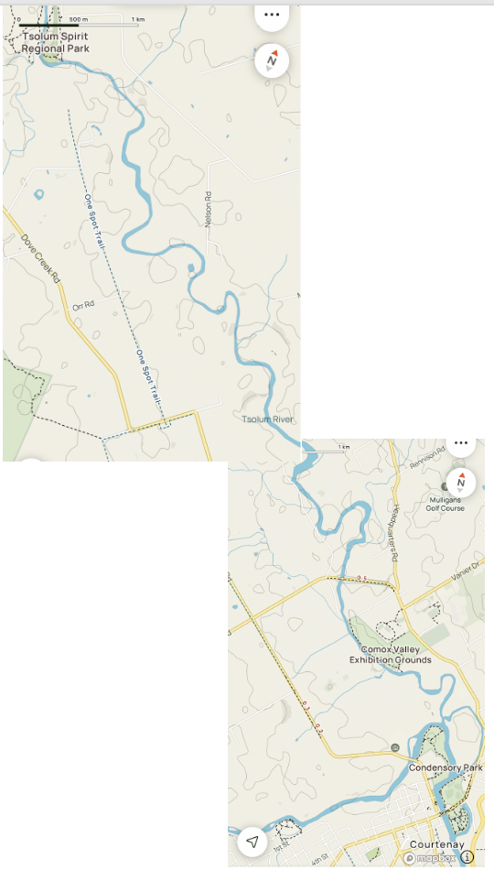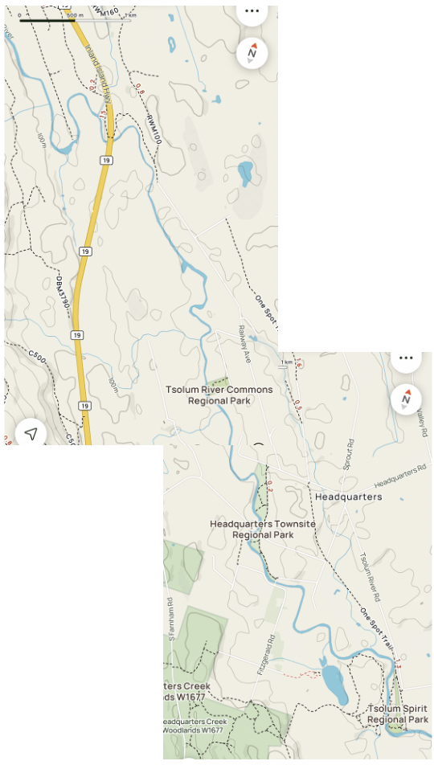

Literature Cited

Beamish R, 2022. The need to see a bigger picture to understand the ups and downs of Pacific salmon abundances. Journal of Marine Science, 2022, 0,1-10 Emeritus Scientist, Pacific Biological Station, Fisheries and Oceans Canada, Nanaimo, V9T6N7 British Columbia, Canada *Corresponding author: tel: +250 758 2574; e-mail: rabeamish@shaw.ca.

Oates A., and K. Adabar 2021. Chillie Creek Fish Kill Investigation. Revised October 15,2021 for Tsolum River Restoration Society. 33pages.

Tripp, D. 2023. Juvenile Coho Salmon Abundance and Survival in Chillie Creek, July 9 – September 23, 2020. For: Tsolum River Restoration Society. PO Box 488, Merville, BC, VOR 2M0. 6pages.

